How does the Decision Tree algorithm work (correct ordering)?

* Select the best attribute using Attribute Selection Measures(ASM) to split the records.
* Make that attribute a decision node and breaks the dataset into smaller subsets.
* Starts tree building by repeating this process recursively for each child until one of the

------------------------------------------------------------------------

Regression trees are needed:

1. when the response variable is complex
2. when the response variable is numeric or continuous
3. when the response variable is string
4. when the response variable is binary

------------------------------------------------------------------------

Classification trees are needed:

1. when the response variable is complex
2. when the response variable is numeric or continuous
3. when the response variable is string
4. are used to separate the dataset into classes
5. when the response variable is binary

------------------------------------------------------------------------

What need to importing to visualize tree

1. import pandas
2. import matplotlib
3. import seaborn
4. from sklearn.tree import export_graphviz

------------------------------------------------------------------------

Whats depth of this tree (in following picture)

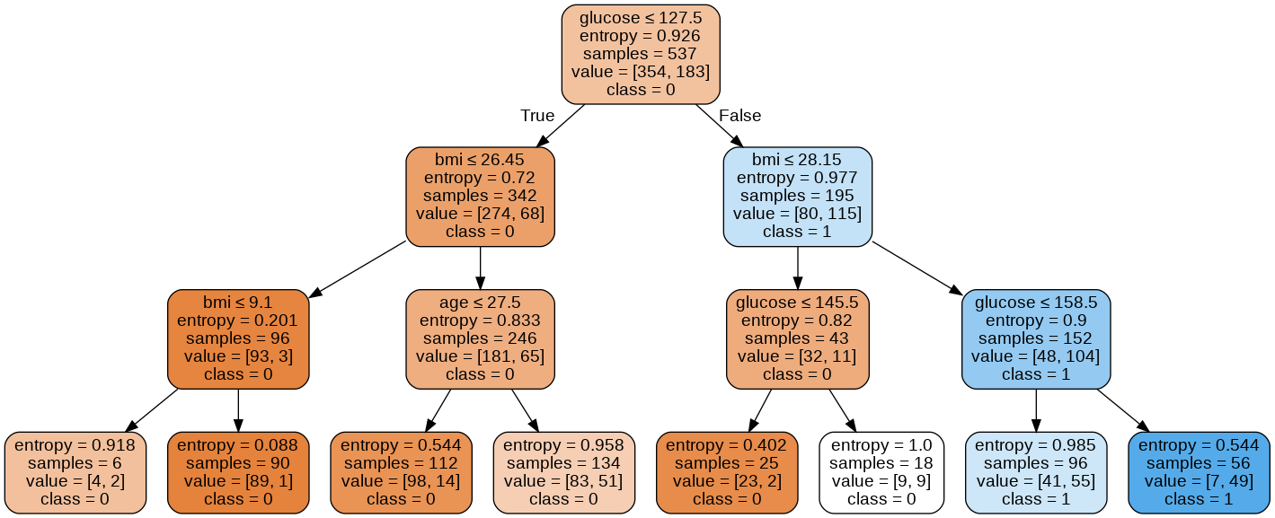

1. 8
2. 4
3. 3
4. 15

------------------------------------------------------------------------

There are two code samples (first and second)

# Create Decision Tree classifer object

clf = DecisionTreeClassifier()

and

# Create Decision Tree classifer object

clf = DecisionTreeClassifier(criterion="entropy", max_depth=3)

which code is faster and more accurate?

1. First, because it write faster
2. First, because code not overloaded with parameters
3. Second entropy improves accuracy and depth prevents the tree from retraining

------------------------------------------------------------------------

<https://medium.com/pursuitnotes/decision-tree-regression-in-6-steps-with-python-1a1c5aa2ee16>

<https://www.datacamp.com/community/tutorials/decision-tree-classification-python>